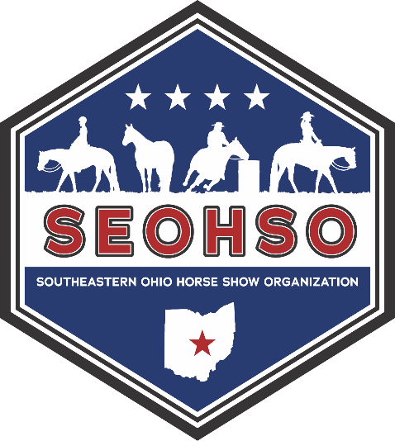
SEOHSO SPONSORSHIPS
The Southeastern Ohio Horse Show Organization strives to provide a quality, affordable, family-friendly open horse show that promotes equine events for all ages. These shows provide a venue for area youth and adults to show their equine partners. All six 2026 SEOHSO open shows will be held at the Hartford Fairgrounds in Croton, Ohio. Pleasure May 2/3, July 11/12, Sept 5/6. Contesting May 10, June 7, and Sept 28.
SEOHSO is a non-profit organization with no paid positions, we run solely off volunteers and members. To keep our shows affordable, we are in need of support from our local businesses. Every sponsorship goes towards the cost of arena rental, insurance, judge fees, ribbons, and awards. We are registered with the IRS as a 501(c)(3) so all donations are tax deductible.
SPONSORSHIP OPTIONS:
PLATINUM - $500 AND OVER
Includes: Sponsor’s name/message announced during shows and posted on Facebook, Name/logo printed on back of SEOSHO t-shirts, and name/logo displayed on banners around arena
GOLD - $300-$499
Includes: Sponsor’s name/message announced during shows and posted on Facebook, and Sponsor’s name/logo printed on back of SEOSHO t-shirts
SILVER- $100-$299
Includes: Sponsor’s name/message announced during shows and posted on Facebook
$100 JACKPOT CLASS ($100 per show or $300 for season)
Includes: Sponsor’s name/message announced during shows and posted on Facebook
REGULAR CLASS ($50 per class or $150 for season)
Includes: Sponsor’s name/message announced during shows and posted on Facebook
Please note: Script for announcements must be provided, as well as logo and/or banner. Thank you!
We greatly appreciate your time and consideration of supporting SEOHSO!
Rev Date: 11/2025

