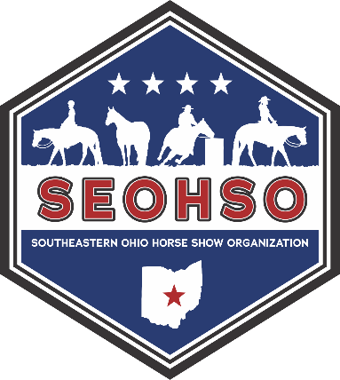
Southeastern Ohio Horse Show Organization
SPONSORSHIP FORM
Sponsor Name ____________________________________________________________
Address _________________________________________________________________
Phone __________________________________________________________________
Point of Contact Name _____________________________________________________
Phone ___________________________________________________________________
Sponsorship Type and Amount _______________________________________________

Check if applicable: □Script for announcements provided □Company Logo provided

Please make check payable to SEOHSO and mail to:
Terri Ruediger, 8242 Night Heron Ln, Pickerington OH 43147

For questions, please call or message
President: Terri Ruediger at 614-203-3153
Vice President: Kim Bobb at 614-203-7397
SEOHSO Email: seohso2023@gmail.com

FOR OFFICE USE ONLY
Cash or Check # | Amount | Date | Initials

_ _ _ _ _ _ _ _ _ _ _ _ _ _ RECEIPT_ _ _ _ _ _ _ _ _ _ _ _ _ _ _ _ _

Southeastern Ohio Horse Show Organization EIN 87-1155041
Cash or Check # | Amount | Date | Received By
Rev Date: 11/2025

